**ek,z** 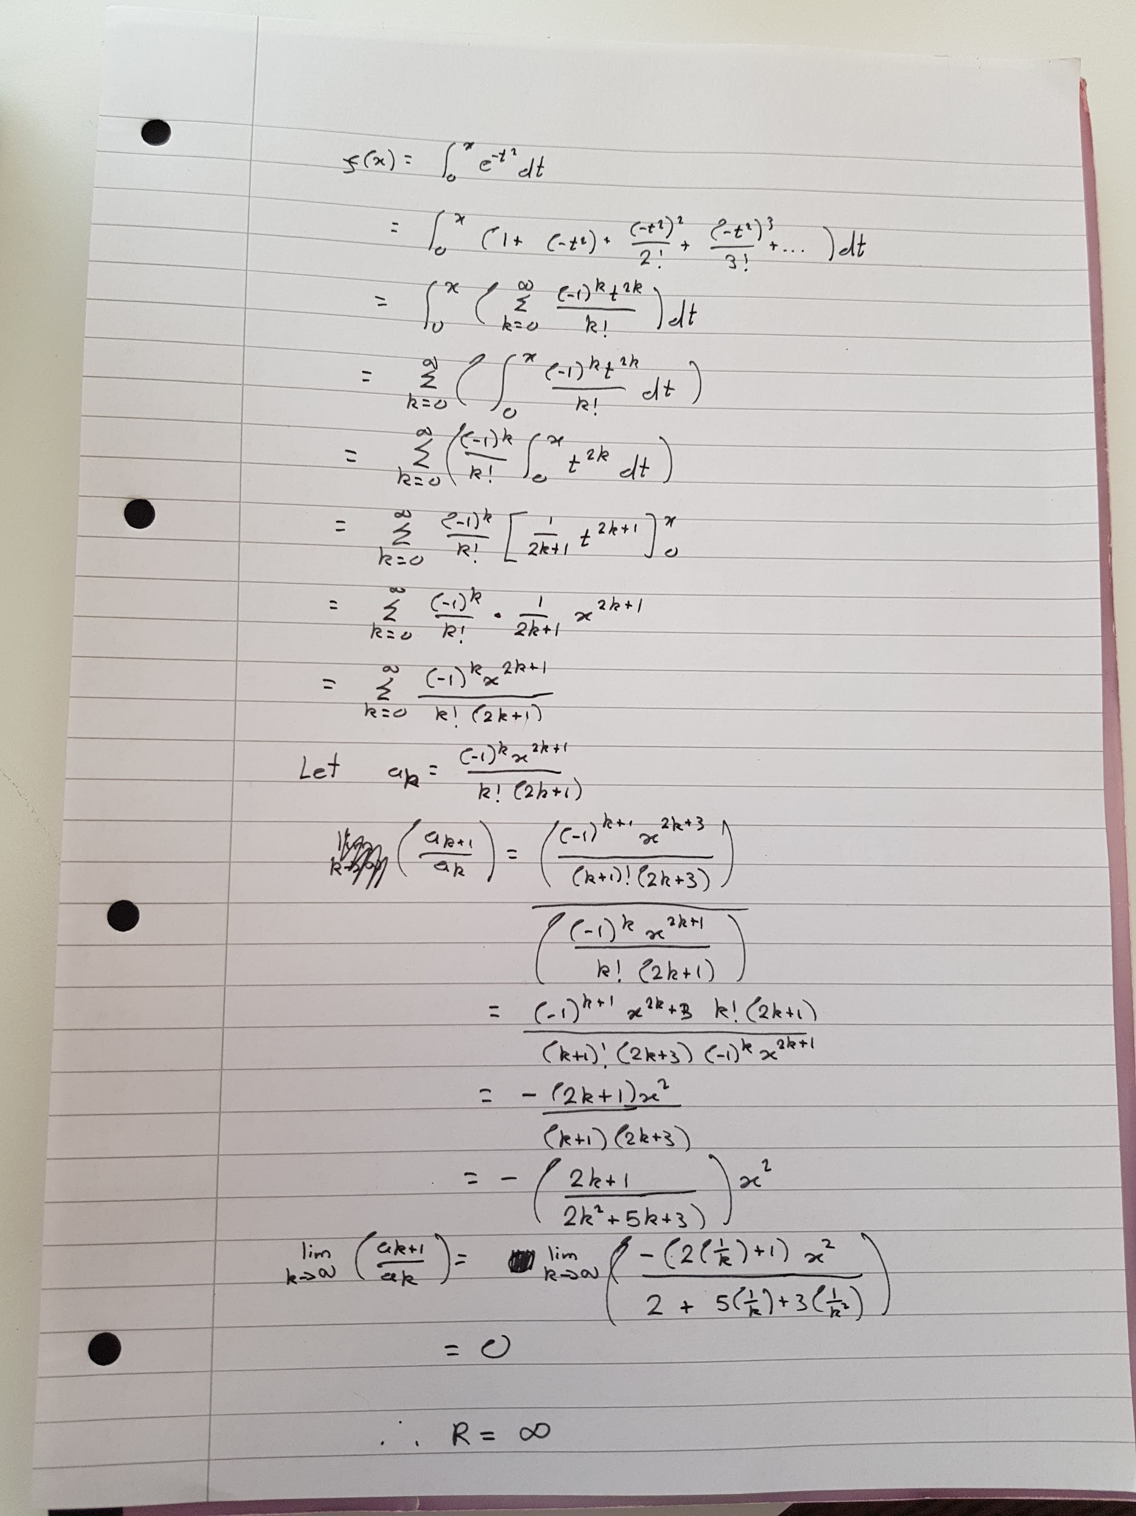

**Mathematical Methods**

i am bad at maths pls halp

**1a**

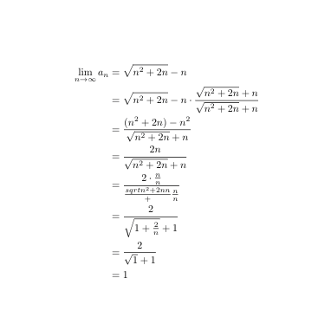

(I forgot all the s sorry)

**1b**

Apply D’Alembert’s ratio test. Do a bit of rejigging, should get the limit as 4. This is greater than 1, so the series divergeeepppppes.

**1c**

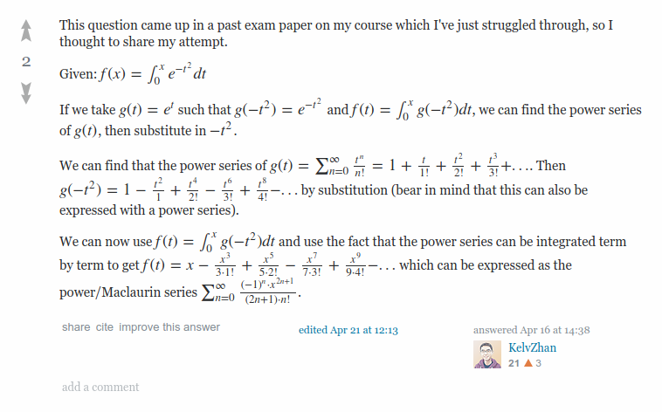

Radius of convergence is infinity

**1d**

(For a power series solution attempt scroll further down)

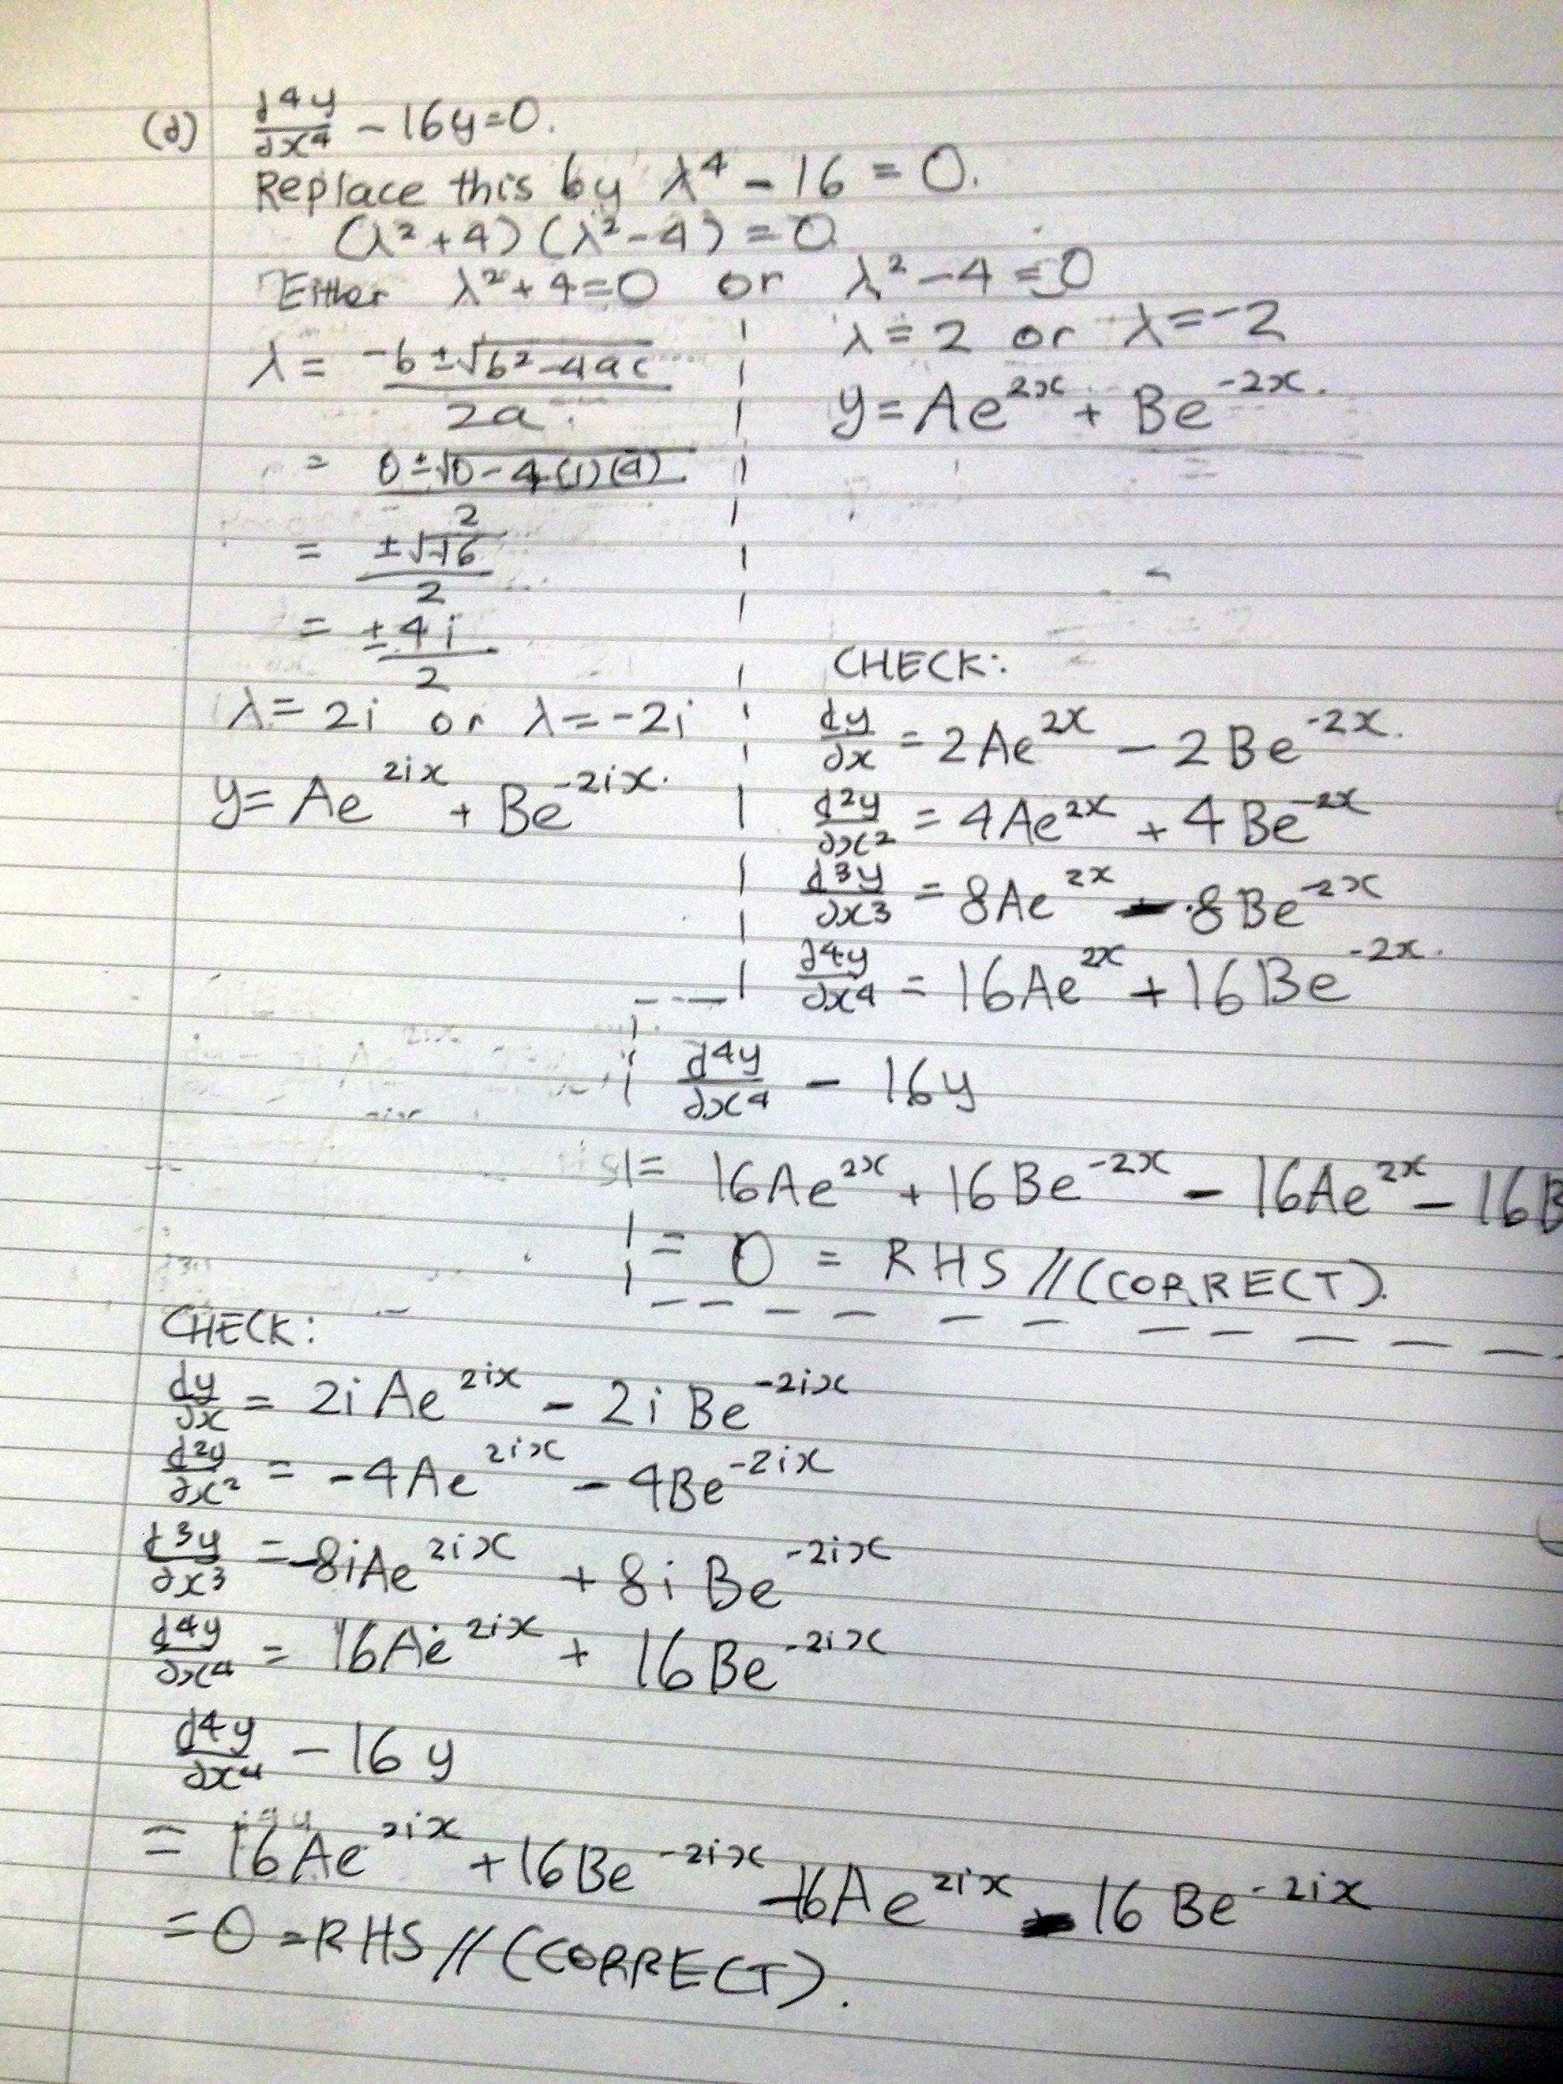 tttuuyuggu.gg.gu

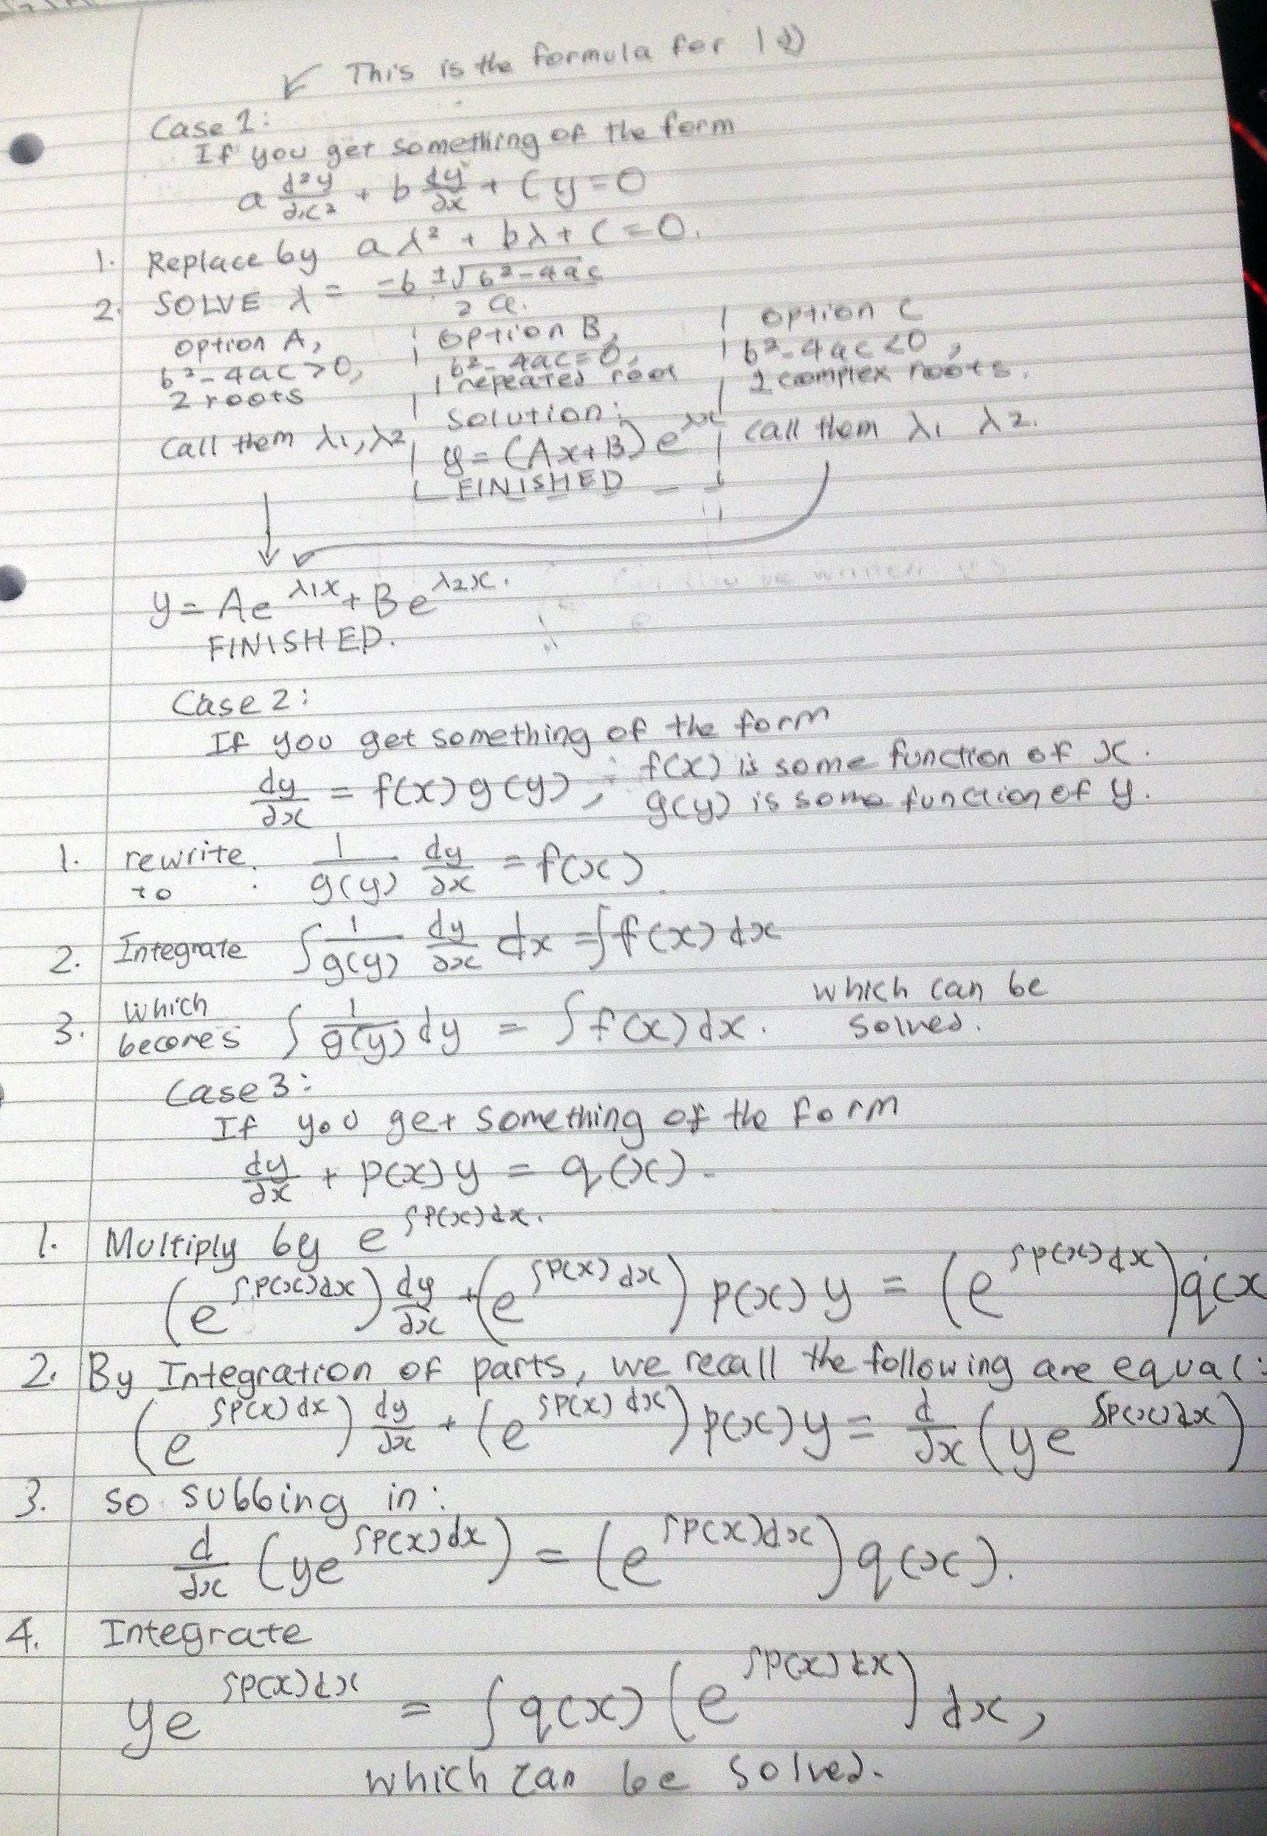Kelvin’s attempt: I think I’m missing steps since for a fourth order ODE there should be four independent solutions? This question may be f  
Edit: see Viet’s comment belowh

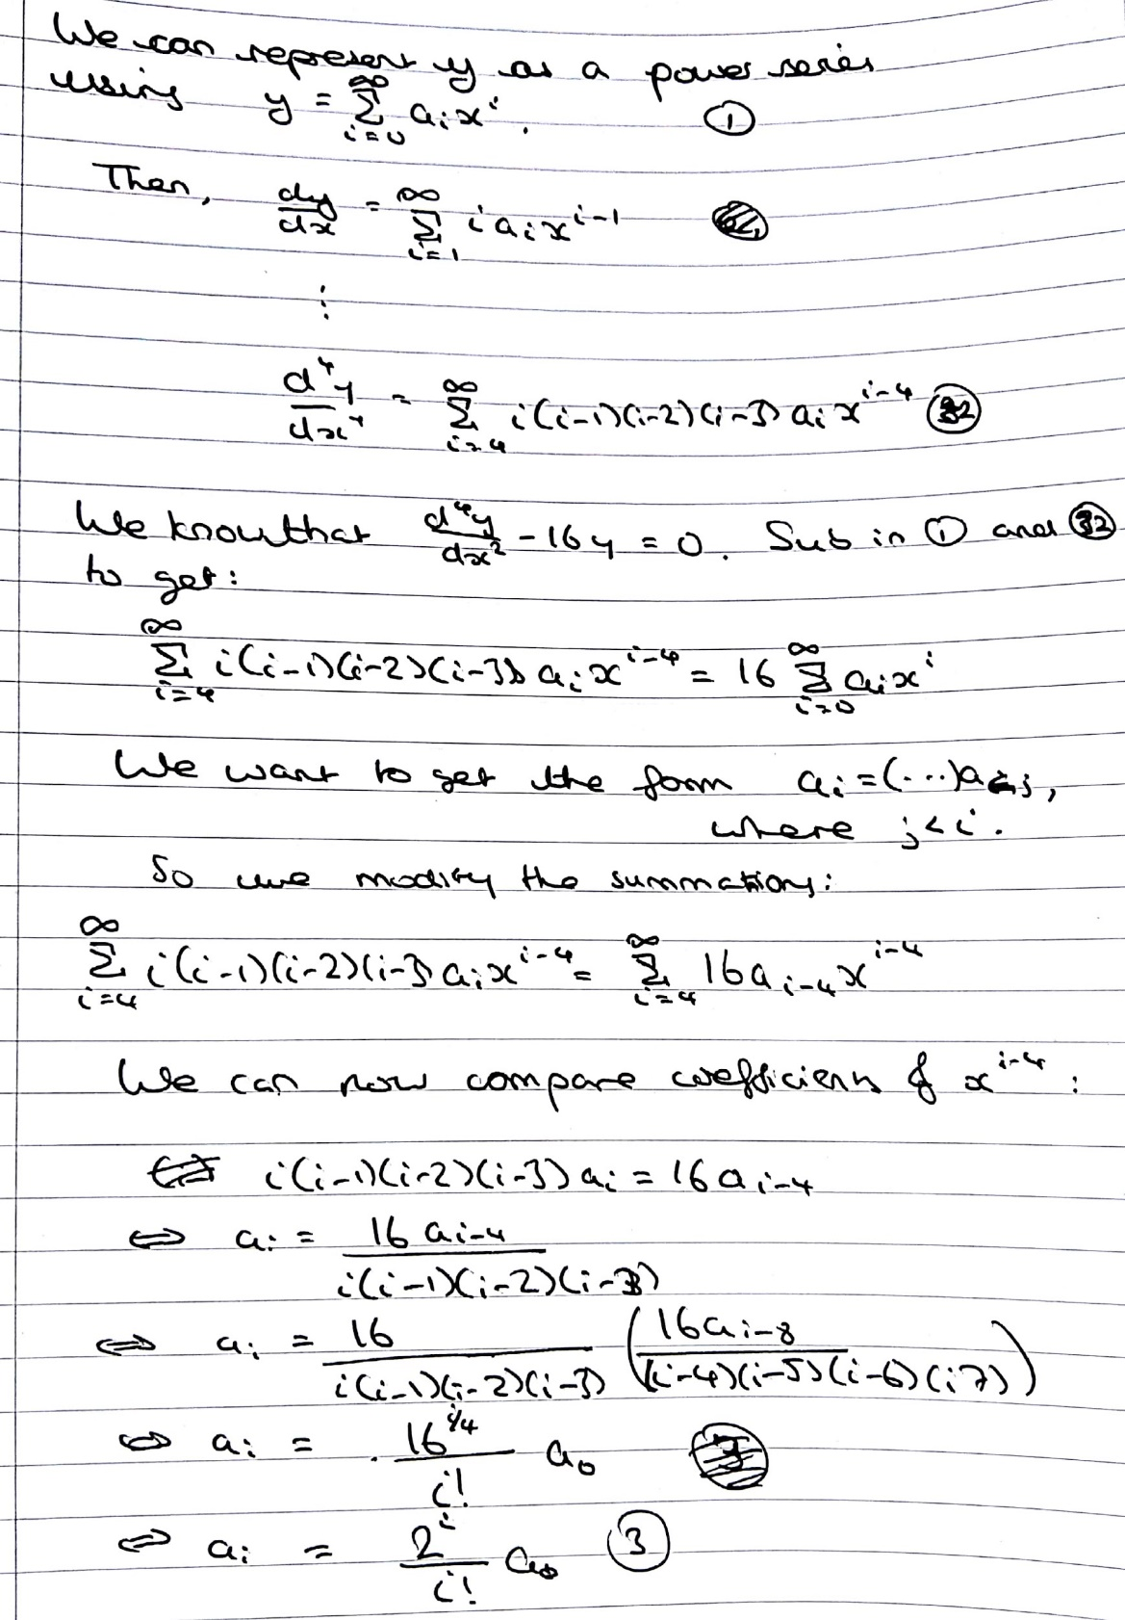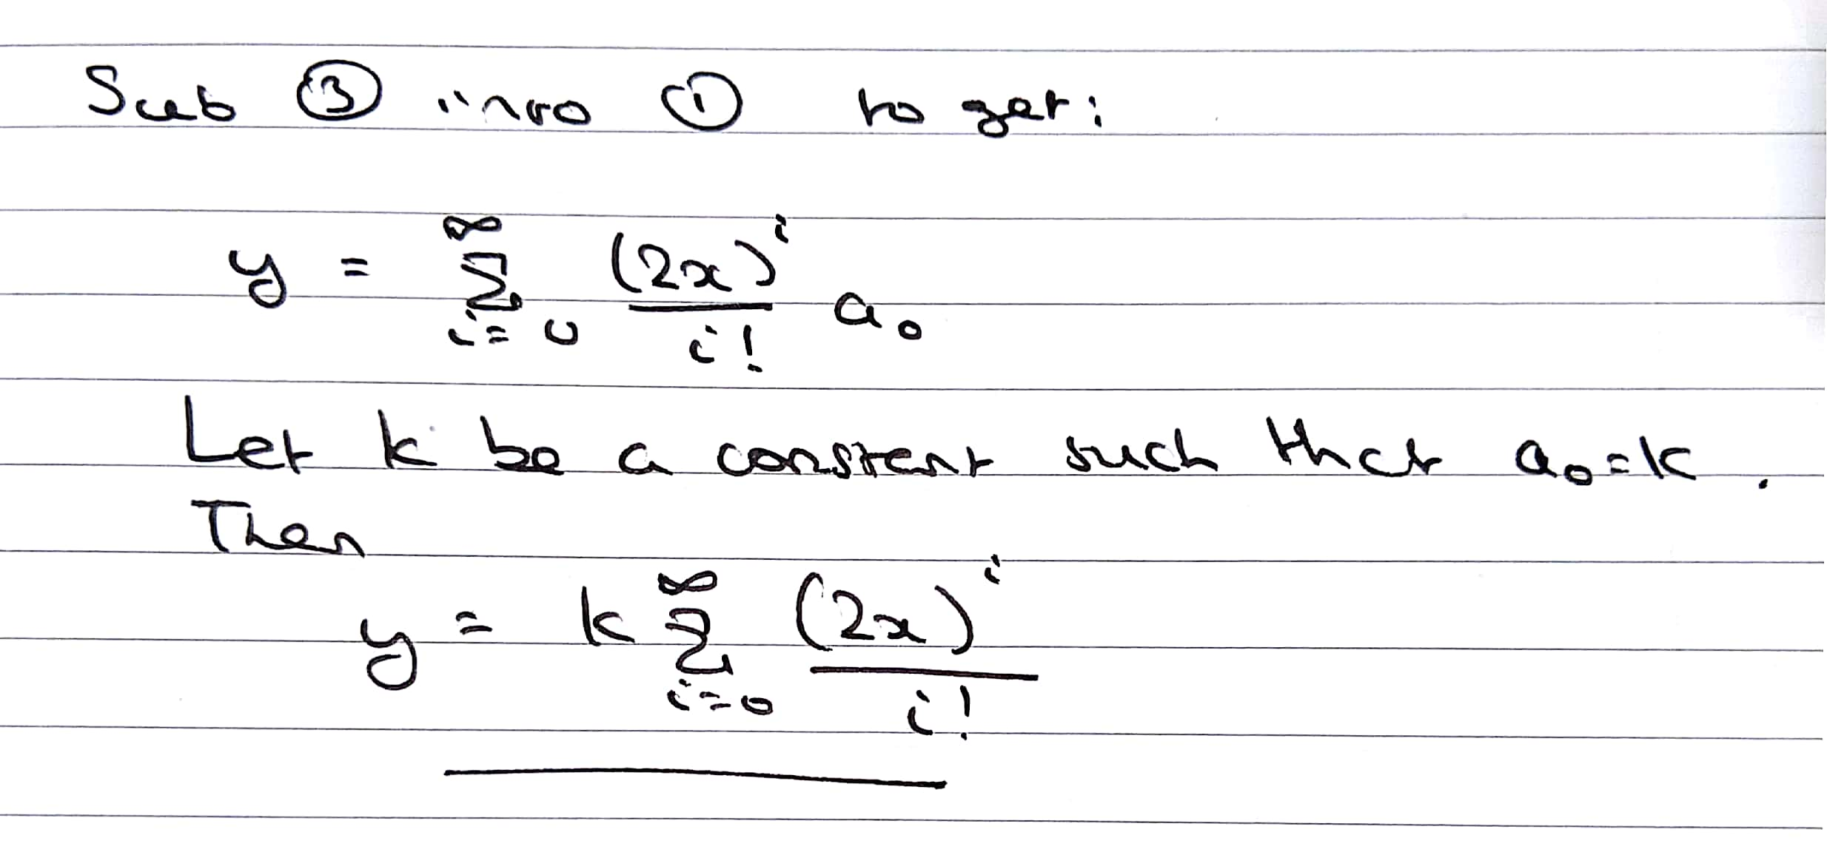

(so )

<https://www.youtube.com/watch?v=H3UnO0fHpao>

The solution should be: y =

= 16

2.a.i

Page Rank, Numerical Stability, Principal component analysis

T2.a.ii

The first one is diagonalisable

The second is not diagonalisable, via argument about algebraic multiplicity

2.a.iii

1. 0,4,5,-2
2. 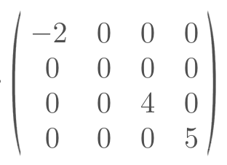
3. Eigenspace: [2,1,0,-1]

Projection: [⅔, ⅓, 0, -⅓ ]

Distance: 1/sqrt(3)

2.b.i

1. No, not closed under multiplication
2. No, doesn’t contain (0,0)
3. No, not closed under addition
4. Yes

2.b.ii